COOPERATIVE LAB MODULE TPB1.01
Three-point Beam Bending

BROAD GOAL: To experimentally measure stiffness and strain in a beam in 3-point bending.

SPECIFIC OBJECTIVE: To generate curves of deflection, axial strain, mid-beam shear strain, and peak compression strain vs. load curves (with at least 7 well-spaced points) of a beam in three-point bending, along with geometry measurements sufficient to determine area moment of inertia, and internal load distributions.

DESCRIPTION OF TEST STAND
The test stand consists of an Instron XXX test system with axial load cell and 3-point bending apparatus, VIC-EDU Digital Image Correlation (DIC) system, and computer data acquisition and storage system.

PROCEDURE
- Don Safety Glasses for Mechanical Testing Phase.
- Measure and record in the table all beam dimensions required, using calipers (width, thickness) and tape measure (length)
- (Measure and record the beam weight or mass.)
- (Paint Beam lateral surface with flat white spray paint if necessary. Label Beam if necessary.) Record Beam ID #
- Apply speckle pattern using roller and ink pad. Manually add edge dots if needed (discuss with technician).
- Mount beam centered between supports, in stiff orientation. (Measure and) Record beam length between supports (see scale).
  - DIC system and Instron will be set up by technician prior to lab.
  - Calibration images will be recorded by the technician prior to the lab.
  - Check that DIC system is level and perpendicular to the beam specimen, and that beam specimen is level.
- Position the loading head near the beam. Load the beam to 500N. Unload to 0N.
- Record initial DIC 0N load DIC image.
- Load the beam to 500N. Record DIC image. Repeat, adding load in 500N increments and record additional DIC images up to specified Maximum Load. (Use Max Load of 3000N for 1” x ¼” x 19cm Aluminum 6061-T6511 beam.)
- Return to 0N load. Record final DIC image.
- Open DIC software. Run calibration images.
- Fill in the data table using values from the DIC contour plots. For each load, record:
  - Maximum transverse deflection (under beam load point)
  - Maximum axial normal strain at the beam center (load point), low (tension) side
  - Maximum compressive strain at the beam center (load point), actuator side
  - Mid-beam (half-way between support and load point, centerline) shear strain

NAMES: Jaine Ratush, Zeshui Song, Bertrand Juan

Team: 8 Beam #: 8 Date: 11/05/26
Parameters Table |  |  | Value |  | Uncertainty |  | Units
Beam | (Mass) |  | 139 |  | 0.2 |  | g
8 | Length |  | 30.4 |  | 0.05 |  | cm
8 | Width |  | 2.55 |  | 0.002 |  | cm
8 | Thickness |  | 0.66 |  | 0.002 |  | cm
8 | Color |  | white
8 | Material |  | Al-6061
Apparatus Support Span |  |  | 19 |  | 0.05 |  | Cm
Post Processing Parameters
Load Point (XLP, YLP) |  |  |  | (56.8398, 7.30807) mm
Midpoint (XMP, YMP) |  |  |  | (9.3398,-0.41155) mm
Contact Displacement |  |  |  | 0.2052 mm at 12.36 s
Meas # |  | Load |  |  |  | Displacement |  | e_xx |  |  | V | e_yy | e_xy
Units |  | N |  |  |  | mm |  | strain |  |  | mm | strain | strain
1 |  | 0 |  |  |  | 0 |  | -3.40E-19 |  |  | 0 | -3.38E-18 | -1.36E-18
2 |  | 500 |  |  |  | 0.4001 |  | 0.000432785 |  |  | -0.178265 | -0.001147 | 3.8478E-06
3 |  | 1000 |  |  |  | 0.5746 |  | 0.000986745 |  |  | -0.3230433 | -0.0008753 | -3.722E-05
4 |  | 1500 |  |  |  | 0.7371 |  | 0.001431971 |  |  | -0.4621725 | -0.0008321 | -6.803E-05
5 |  | 2000 |  |  |  | 0.8912 |  | 0.001887982 |  |  | -0.6018277 | -0.0007432 | -9.289E-05
6 |  | 2500 |  |  |  | 1.044 |  | 0.002341487 |  |  | -0.7396601 | -0.0005742 | -0.0001551
7 |  | 3000 |  |  |  | 1.1964 |  | 0.002764249 |  |  | -0.8777449 | -0.0005182 | -0.0001717
8 |  | 0 |  |  |  | N/A |  | 0.000118023 |  |  | -0.0335577 | 3.544E-05 | 1.8491E-05
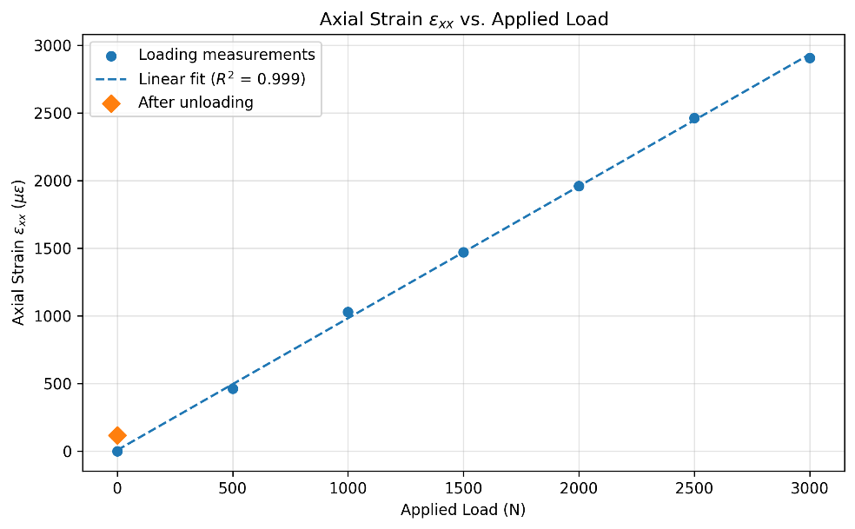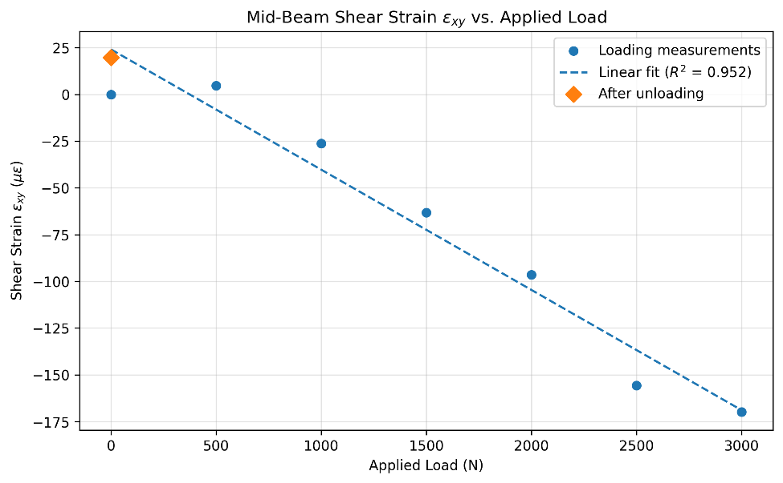
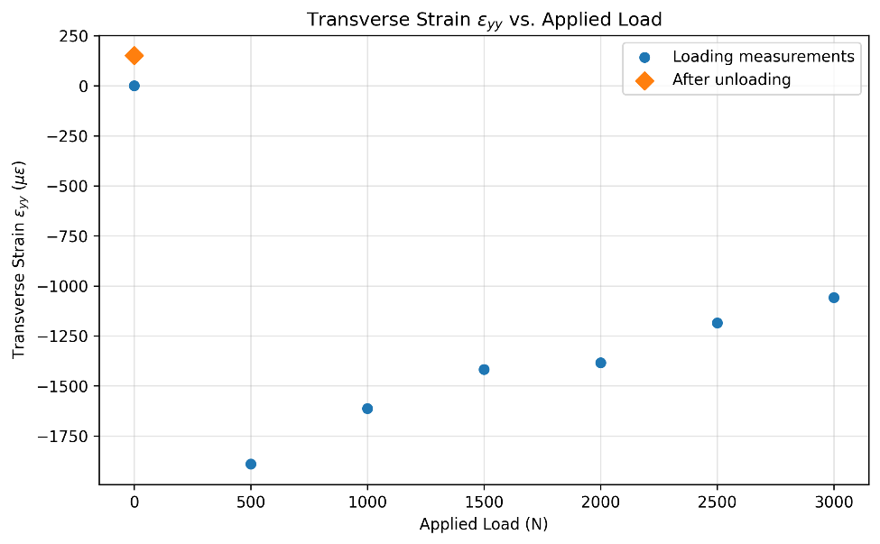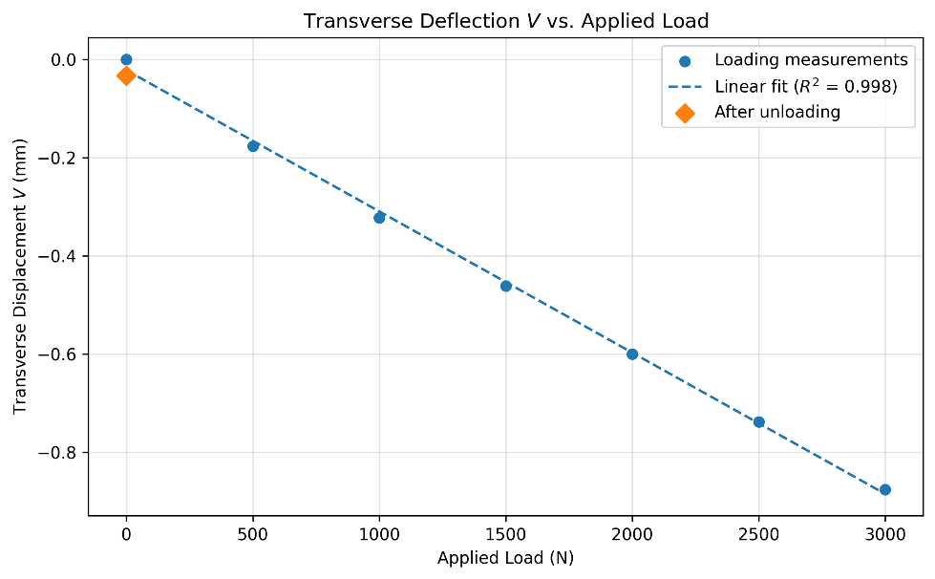
The trend shown in the transverse strain plot is unusual. Although the strain is compressive, as expected, its magnitude decreases with increasing load. This suggests either inaccuracies in the measured data or other factors affecting the strain distribution, such as changes in the contact area or shifts in the location of loading point.

